Prototype Model

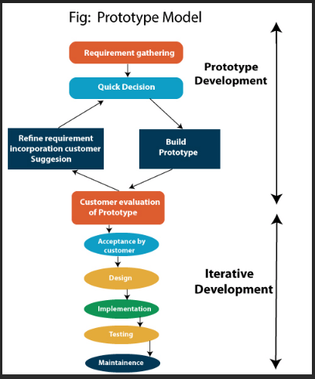

* **Early Prototype Creation**: It involves quickly creating a prototype that demonstrates some aspects of the intended system's functionality
* **User Feedback**: Users are actively involved in providing feedback on the prototype, which helps in refining requirements and identifying changes early.
* **Requirements Elicitation**: It helps in eliciting and validating requirements through concrete demonstrations rather than abstract discussions.
* **Risk Reduction**: By identifying potential issues early through prototype testing, it helps in mitigating risks associated with misunderstandings or changing requirements.
* **Iterative Development**: Prototypes can undergo multiple iterations based on user feedback, gradually improving towards the final product.
* **Visual Representation**: It provides stakeholders with a visual representation of the system, making it easier to understand and validate requirements.
* **Clarification of Requirements**: It facilitates clearer communication between stakeholders, developers, and users, reducing ambiguity in requirements.
* **Time and Cost Efficiency**: It can potentially reduce overall development time and costs by addressing issues early in the development lifecycle.
* **Flexibility**: Allows for flexibility in requirements and design changes, as the prototype can be modified and refined based on feedback.
* **Final System Development**: Once requirements are stabilized and validated through prototypes, development can proceed to build the final system with greater confidence.

The prototype model is particularly useful in projects where requirements are not fully understood or may change, as it allows for early validation and adaptation.

Iterative Model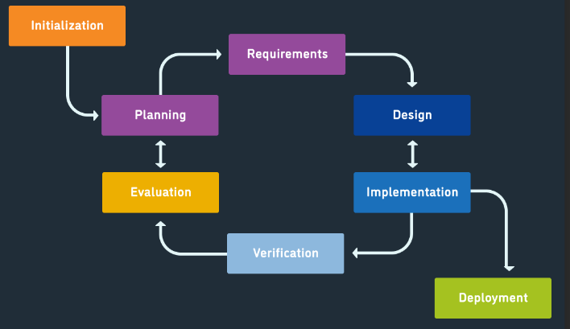

* **Incremental Development**: The software development process is divided into smaller parts or iterations, each producing a partial version of the final product.
* **Feedback Loop**: Each iteration involves feedback from stakeholders, users, and testers, which helps in refining requirements and design.
* **Progressive Iteration**: The software evolves through successive iterations, with each iteration building upon the previous one.
* **Risk Management**: It allows for early identification and mitigation of risks by addressing high-risk components or functionalities early in the development process.
* **Flexibility**: It accommodates changes and improvements in requirements throughout the development lifecycle, as each iteration can incorporate new or modified features.
* **Quality Focus**: Each iteration focuses on producing high-quality software components, which are integrated into the evolving product.
* **Testing and Evaluation**: Continuous testing and evaluation occur throughout each iteration, ensuring that the software meets quality standards and user expectations.
* **Customer Involvement**: Customers and end-users are involved throughout the process, providing feedback and validating the evolving product.
* **Adaptability**: It is suitable for projects where requirements are not fully known upfront or may change over time, allowing for adaptation based on feedback and evolving needs.
* **Deployment Readiness**: At the end of each iteration, there is a potentially shippable product increment, which can be deployed if needed, providing early business value.

Overall, the iterative model promotes a disciplined approach to software development while allowing flexibility to accommodate changes and uncertainties, leading to improved quality and customer satisfaction.Top of Form

Spiral Model

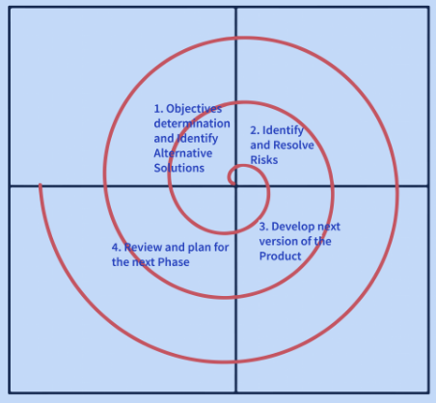

* **Iterative Approach**: The Spiral Model is iterative, allowing for incremental releases of the software or system.
* **Risk Management**: It focuses heavily on risk assessment and mitigation strategies throughout the project. Risks are identified and resolved early in the development process.
* **Phases**: It is divided into several phases, typically including Planning, Risk Analysis, Engineering, and Evaluation. Each phase represents a segment of the project.
* **Flexibility**: It allows for changes and refinements to be made to the software based on ongoing customer feedback and evaluation.
* **Prototyping**: Prototyping plays a significant role in the Spiral Model, helping to visualize requirements and gather early feedback.
* **Progressive Development**: The software evolves through multiple iterations, with each cycle adding more features and functionality.
* **Documentation**: Each phase in the Spiral Model requires documentation, ensuring clarity and traceability throughout the project.
* **Communication**: Stakeholder involvement is crucial, with continuous communication and feedback loops built into each iteration.
* **Verification and Validation**: Continuous testing, verification, and validation ensure that the software meets quality standards and user expectations.
* **Deployment Readiness**: The Spiral Model aims to produce a product that is increasingly refined and ready for deployment with each iteration, balancing development effort with project risks and constraints.

Overall, the Spiral Model is suitable for large-scale projects where early risk assessment and management are critical, and where requirements are likely to evolve over time. It provides a structured approach while allowing flexibility to accommodate changes and uncertainties in the development process

Rapid Application Development Model

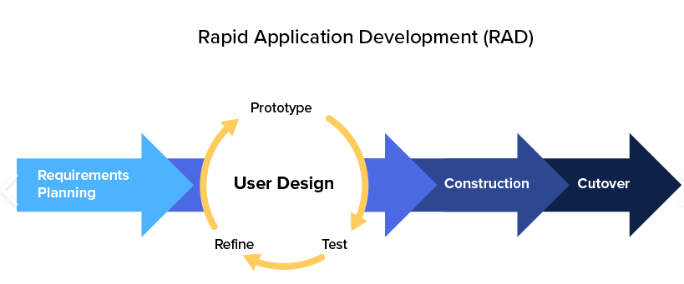

* **Iterative and Incremental**: RAD follows an iterative and incremental approach, where the project is divided into smaller modules or prototypes that are developed individually and then integrated.
* **User Involvement**: RAD emphasizes active user involvement and feedback throughout the development process to ensure the end product meets user expectations.
* **Prototyping**: Prototyping plays a central role in RAD, with quick prototypes developed to validate requirements and gather feedback early in the project lifecycle.
* **Time-boxed Development**: RAD projects are time-boxed, meaning each prototype or iteration is developed within a fixed timeframe, typically ranging from a few weeks to a few months.
* **Reusable Components**: RAD encourages the use of reusable components and previously developed prototypes to speed up development and maintain consistency.
* **Collaborative Approach**: RAD promotes collaborative development, involving cross-functional teams that work closely together throughout the project.
* **Flexible and Adaptive**: The RAD model is highly flexible and adaptive to changes in requirements, allowing for adjustments based on ongoing feedback and evolving needs.
* **Focus on Business Value**: It focuses on delivering business value early and frequently by prioritizing essential features and functionalities in each iteration.
* **Risk Management**: RAD incorporates risk management strategies by addressing high-risk aspects early in the development process through prototyping and iterative testing.
* **Tools and Automation**: RAD often leverages rapid development tools and frameworks to accelerate development cycles and improve productivity.

Overall, the RAD model is suitable for projects where time-to-market is critical, requirements are likely to evolve, and there is a need for frequent user feedback and rapid development cycles. It emphasizes speed, flexibility, and user involvement to deliver high-quality software solutions efficiently.

Top of Form

Bottom of Form